Save Money With Home Pedicure
Comments Accepted
You are welcome to Print
I love to have pretty soft smooth feet with a nice color of polish, and when I can I will go to the salon, but there are times that I don’t have the time it takes to go to the salon or the extra money. There's something special about having perfectly polished toes and smooth feet and a diy pedicure can be done at home for mere pennies "saving you a lot of cash", and you will still have a perfect salon quality pedicure.

You might not get your legs massaged like you would at the salon, by the technician, but you can remove the calluses, smooth the bottoms of your feet, trim your toenails and repaint them saving you a bundle. All it takes are a few tools; a foot scrubber or pumice stone, nail polish remover and a file, cuticle nippers, straight edge clippers and a cuticle pusher or orange stick if you have one and *toe separators. (See * below)

I shop at the Dollar Store and have found the pumice stones along with remover, toe separators, files and Epsom salts. So if you did need to purchase items for a pedicure it could cost as little as $5.00 and save you a bunch on salon pedicures.

A little known fact to my readers is that I owned my own salon as a manicurist for 20 years and as many pedicures as I have done and recently been reading tips in magazines, I decided it was time to share how I you can perform a pedicure in less than an hour, you can do it anytime and your diy pedicure will last just as long as a salon service with a tip I learned when I was doing pedicures in my salon.
♥ Shallow tub or bowl, towels, cotton balls, polish remover
♥ Epsom, kosher or table salt or foot soak
♥ Pumice stone, cuticle nippers, straight edge nail clippers, cuticle stick
♥ Lotion or foot cream
♥ Base coat, polish, top coat or quick dry
♥Toe separators or paper towels to weave between toes

Optional: Scrub A pedicure can be performed at home easily by soaking your feet in a shallow bowl or pan of water with Epsom or mineral salts. You can add essential oils, lavender, eucalyptus or peppermint.
First Steps: Removing the polish from your last pedicure is the first step (and because the remover is drying, apply cuticle oil or olive oil and rub into cuticles to soften, let sit will you prepare for the next step
Prepare for soak: You want the tub/container to be large enough for both feet, I found one at the Dollar Store. Fill a tub with hot water, (make sure water is comfortable) enough to cover your feet, add a 1/2 cup Epsom, mineral salts or Pedi soak. The Epsom salts will help soften calluses, remove dead skin while removing embedded dirt. I know that working outside in the summer any dry areas will attract the dirt. If you don’t have Epsom salts on hand you can use kosher or table salt as a substitute. If you like bubbles you could add some bubble bath or a few drops of dish soap.
Soak: Soak your feet 5-10 minutes before you start, I like to setup at the edge of the bathtub so I can add more hot water if I need. After soaking for a few minutes.......
Time to Trim File and Shape: Now is the time to trim toenails, be sure to cut nails straight across, so to prevent ingrown nails. I like to leave a short edge, you won’t want to cut too short.
Avoid the use of a course or metal files as it can damage the free edge of the nail. Instead use a fine emery board or crystal file.
Calluses a Two Step Process: Now that your feet are soft, use the pumice stone to remove calluses, paying attention to your heals and balls of your feet. Be careful here, if you are to zealous, you can remove too much and cause your feet to be sore. I have had this happen at the salon. Return foot to bath and finish second.
For around the cuticle, I prefer not to cut the cuticle to prevent infection. The Epsom salts will remove the dry skin around toe nail during soak.
Exfoliating and finishing for smooth soft feet: If using this next step, empty water and start with a fresh water: For a smooth finish to your feet and legs you can use a scrub from a DIY Coconut Oil Sugar Scrub recipe I found that is really basic, you can make at home. Or a new one I just found Lemon Scrub on Undercover DIY
My Secret Tip for long lasting pedicure: Using your soft file, file downward on the edges, (i.e., see diagram) then smooth the edge of nail, if you have a buffing block, buff the top and edge of nail, this will help your polish to adhere for a long lasting polish job, salon quality! (No Chipping) Rinse feet and dry thoroughly.
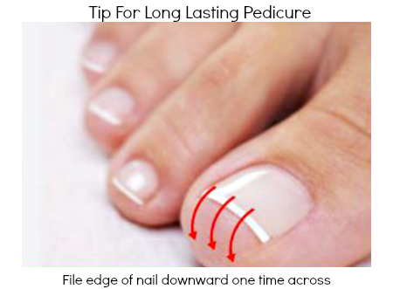
Now you are ready to apply a foot cream or lotion of your choice.
Polishing Tip: *To separate toes use the toe separators or you can take strips of paper towels fold in a narrow strip and wind through toes to keep them from touching while polishing and drying. (i.e., see diagram below) A fan is good as long as it is not to close to help speed drying time and there are products you can buy for this as well.
Be sure there is no oil or lotion on toenails before polishing, you can use a cotton ball and small amount of alcohol to remove residue before proceeding. If using color, use a base coat before polishing.
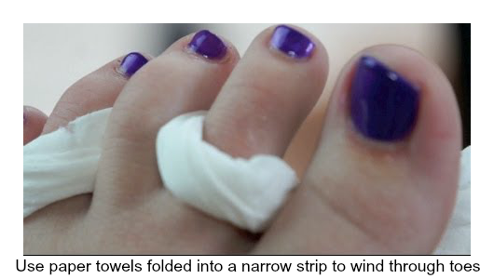
Between pedicures moisturize with lotion or cream, be sure to use sunscreen and touch up polish. If you dont mind wearing socks, at least part of the day, what I like to do is apply a heavy coat of Bag Balm, a product that is actually sold in feed stores or you can find it at Walmart or Walgreen's.

Just knowing that you can do a "pedicure at home" with just a few supplies and the right technique can save you a fraction of the cost of a salon pedicure. But of course, there's nothing wrong in having a salon pedicure for special occasions. You could even have an all-girls night of pedicures or a mom and daughter Pedi-party, one on one time doing pedicures. Hope you found this article useful, there’s a printable version at the bottom

Stop by and find other posts and articles on Oh My Heartsie Girl Weekly Linkups
Written by Karren Haller Oh My Heartsie Girl © 2014

Products that are also available:
